**MULTI AREA OSPF**

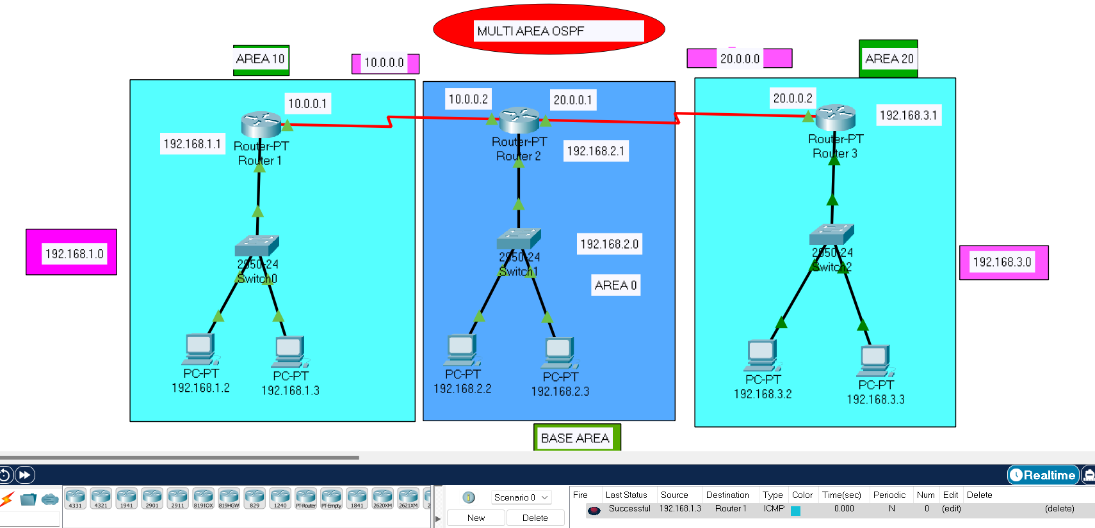

**ROUTER 1:**

Router# enable

Router# configure terminal

Enter configuration commands, one per line. End with CNTL/Z.

Router(config)#router ospf 1

Router(config-router) # network 192.168.1.0 0.0.0.255 area 10

Router(config-router) # network 10.0.0.0 0.255.255.255 area 10

Router(config-router) # end

**ROUTER 2:**

Router# enable

Router# config terminal

Enter configuration commands, one per line. End with CNTL/Z.

Router(config) #router ospf 1

Router(config-router) #network 192.168.2.0 0.0.0.255 area 0

Router(config-router) #network 10.0.0.0 0.255.255.255 area 10

Router(config-router) #network 20.0.0.0 0.255.255.255 area 20

Router(config-router) #end

**ROUTER 3:**

Router# enable

Router# configure terminal

Enter configuration commands, one per line. End with CNTL/Z.

Router(config) # router ospf 2

Router(config-router) # network 192.168.3.0 0.0.0.255 area 20

Router(config-router) # network 20.0.0.0 0.255.255.255 area 20

Router(config-router) #end